**FRETX ALPHA VERSION**

# 

# MAIN FEATURES

* Wifi connection is required for the app to work at the moment.
* Facebook log-in: user must log-in with facebook (i.e.: Wifi connection is required). Once logged-in user, the app will not ask for user log in again until user logs out.
* Bluetooth: user can connect/disconnect Bluetooth device by clicking on “DEVICE not CONNECTED”

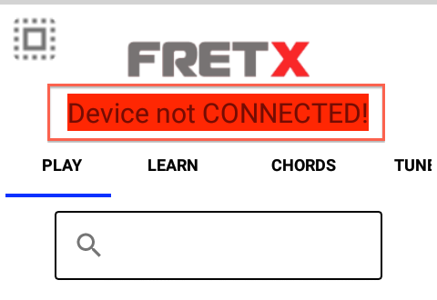

* Side navigation:
* Display facebook user name, profile picture
* Display user’s total score of exercise
* Navigation to user feedback page
* Sign-out

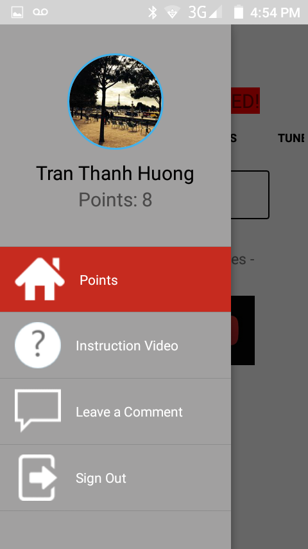

* Amazon web services (AWS):
* The app use Amazon web services S3 database to store and retrieve data.

# FEATURES BY MENU

## Play

* Display list of youtube songs with chords available in AWS database

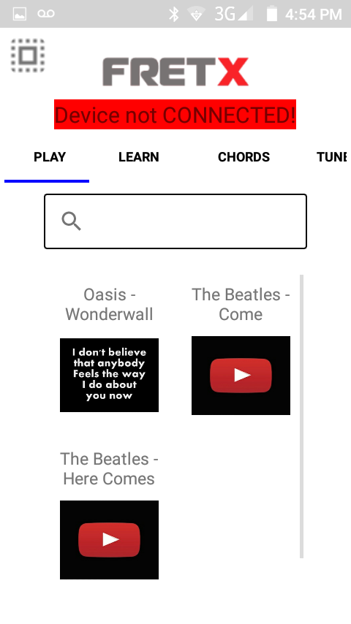

* Stream video from youtube when user click on each video on the list

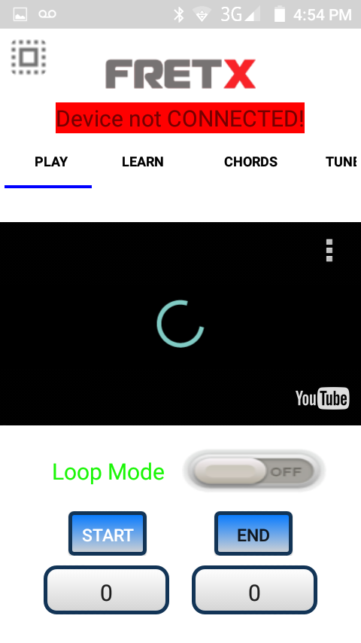

* On back click, go back to list of songs

## Learn

* Display list of available exercises

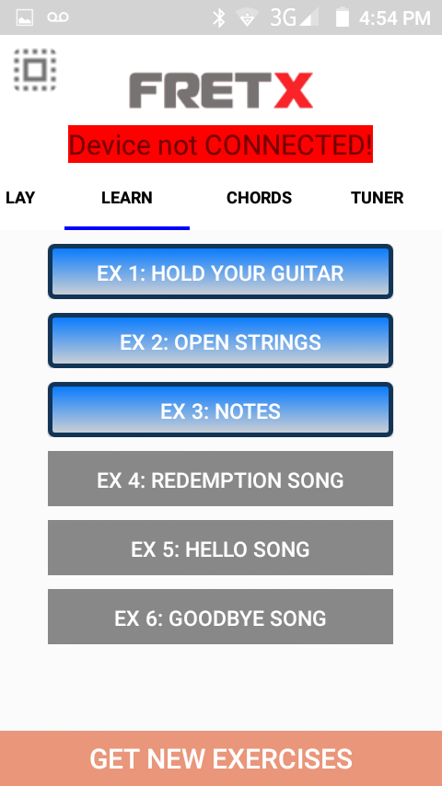

* General rules for exercise list:
* User must start from Exercise 1 and can only move on to next exercise after finishing the previous one
* Exercise buttons are enable only if user has finished all the required exercises
* Each exercise can be with or without video instruction.
* Rules for video exercise:
* If exercise comes with instruction video, after clicking on the exercise button, a video should be display.

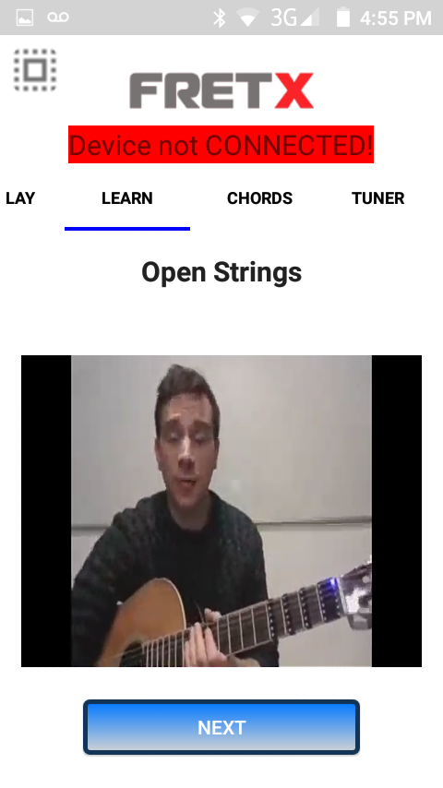

* After the video, the exercise can continue with note practice or directly to result screen.

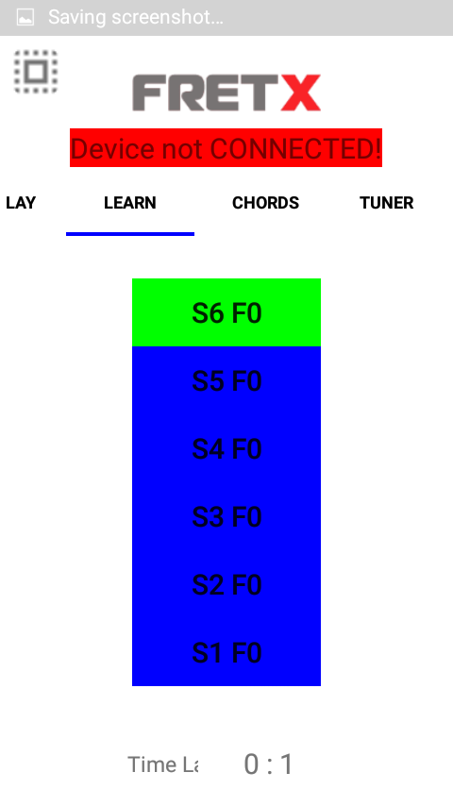 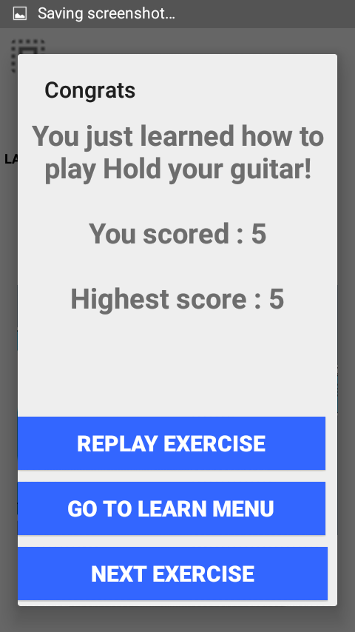

* Rules for note exercise:
* If exercise comes with note practice, after finishing the video, a list of notes will be display for user to practice.
* Each time 6 notes will be displayed on the screen. Format: S<number>F<number>. S stands for string, F stands for Fret, i.e. S6F1 stands for String 6, fret 1.

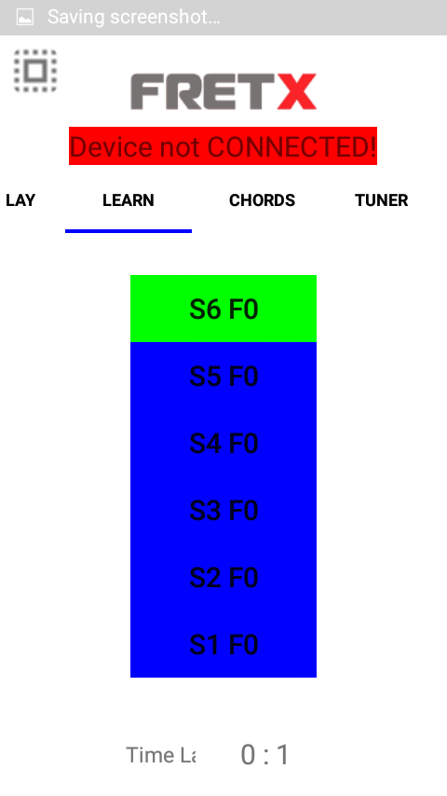

* User plays each note in sequence. Note highlighted in green is the note that user needs to play; other notes are marked in blue.
* If user plays correctly, a success sound will be played, and next note will be highlighted.

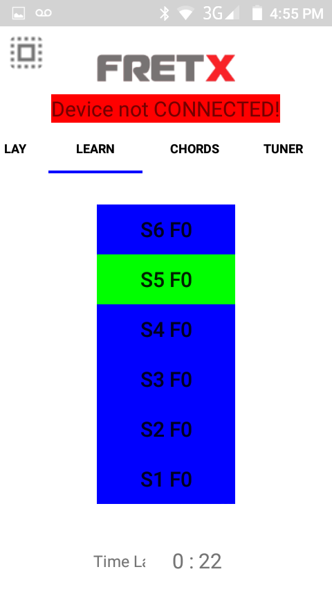

* Time counter is used to calculate score:
  + < 40s -> score 5
  + < 60s -> score 4
  + < 80s -> score 3
  + < 100s -> score 2
  + otherwise -> score 1
* Only highest score is stored in user history. If user redos the exercise and score less than his/her highest score, the lower score will not be saved.
* Exercise is completed when user has played all the notes twice. Score will be added to total score of the user. Result screen will be displayed with user score.

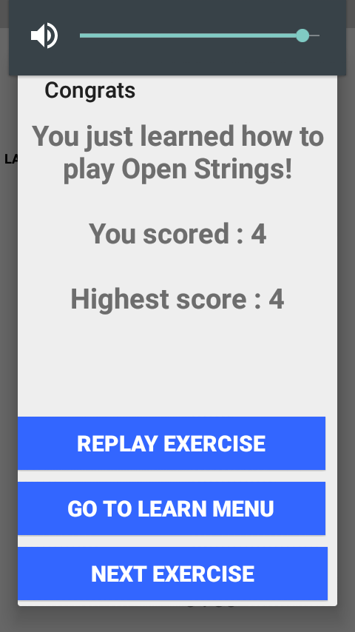

* Rules for result screen:
* Result screen is displayed after the exercise is completed
* Result screen displays congratulation message, user highest score, current score
* User can choose to redo the exercise
* Or Go to exercise list
* Or Go to next exercise
* If this is the last exercise, next exercise button will not be displayed.

 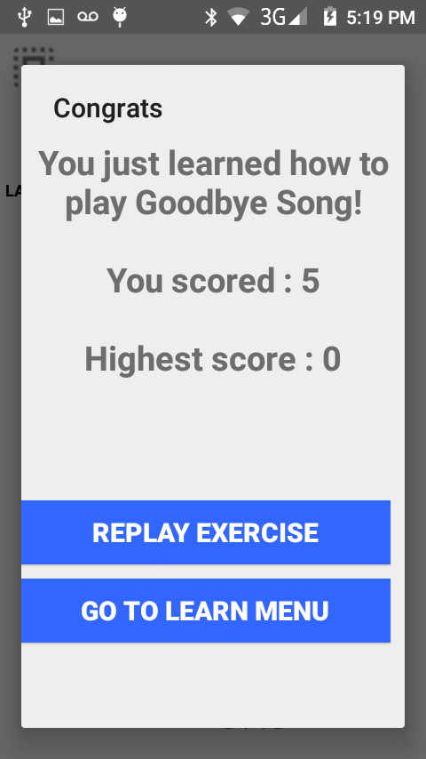

* Click on “Get New Exercise” to download new exercises from the server.

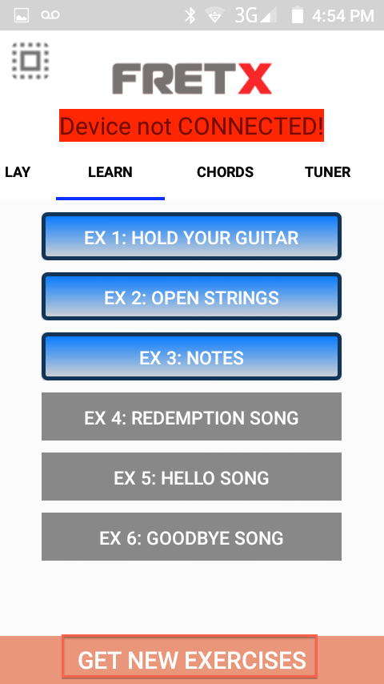

## Chord

* Display chord image and sound when user click on the chord image

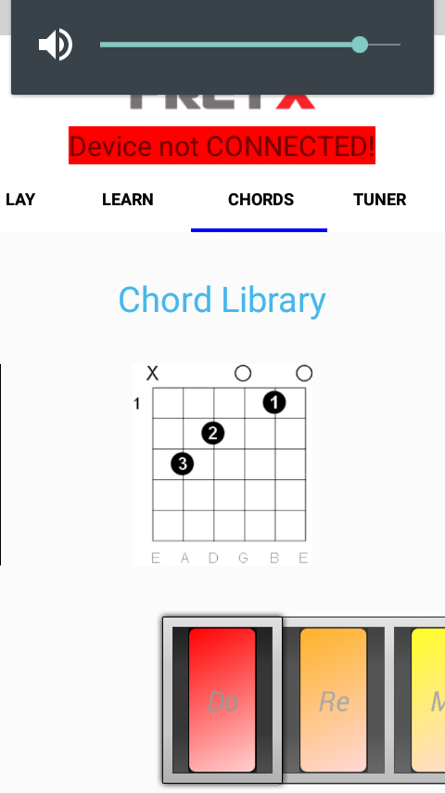 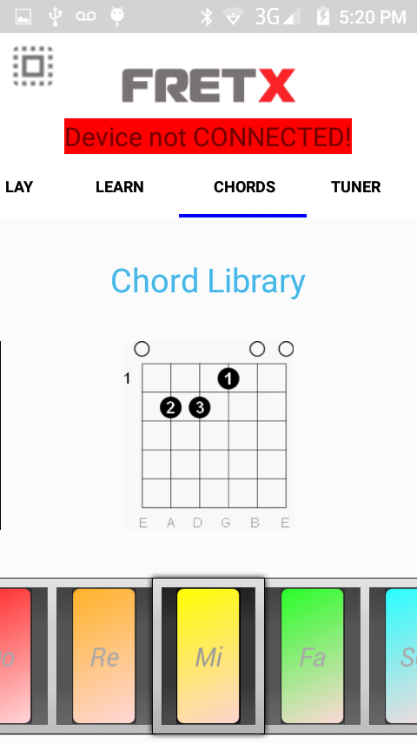

## Tuner

* Use for guitar tuning.
* To tune the string, click on the corresponding button and tune until the red line turns blue and is inline or very close to the green line in the middle.

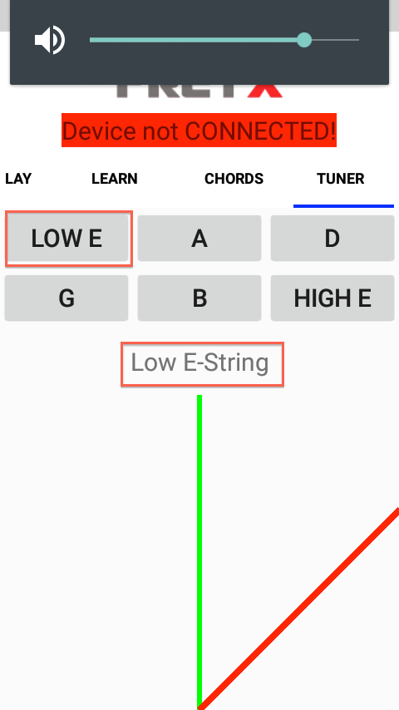 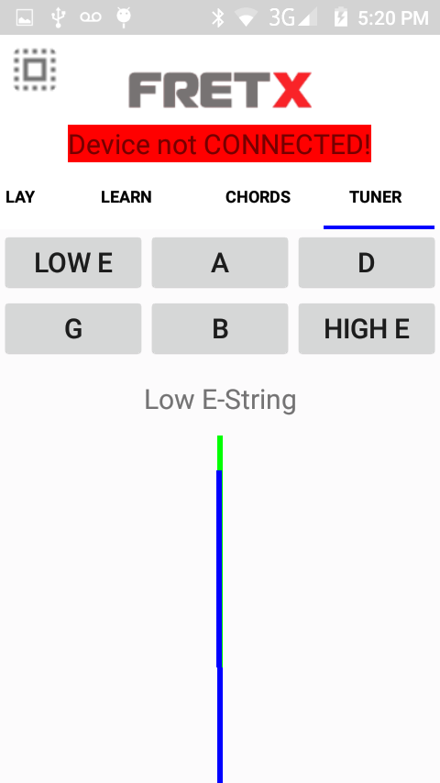

# CRITICAL ISSUES

* Testing with WIFI disconnected
* Testing with 3G, 4G connection
* Crash tests: random tests to detect crash
* Back button tests (function not yet developed)
* Sound detection should only be running in learn menu or tuner menu
* Testing with different android versions, screen resolutions